Tutorial – 9.2

**Aim:** write a shell script to input two no’s from the user and perform addition, subtraction, multiplication and division.

**Code:**echo "Enter two numbers:"

read num1

read num2

# Addition

sum=$((num1 + num2))

echo "Addition result: $sum"

# Subtraction

sub=$((num1 - num2))

echo "Subtraction result: $sub"

# Multiplication

mul=$((num1 * num2))

echo "Multiplication result: $mul"

# Division

div=$((num1 / num2))

echo "Division result: $div"

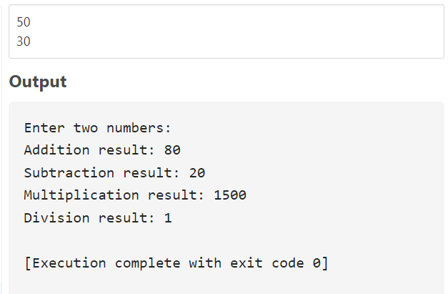**Output:**